Project One Proposal:

* Team Members:
  + Penelope A.
  + Jenny B.
  + Phil M.
  + Daniel T.
* Title: Couch to Cook
* Project Description:
  + A site that allows you to select ingredients you already have, to make a nutritious and delicious recipe
* API’s used: YouTube (specific channel ID) and USDA Nutrition Facts
* Sketch:

1. Homepage
   1. Select Language – change to spanish
   2. Simple how it works explanation
   3. Next or continue button

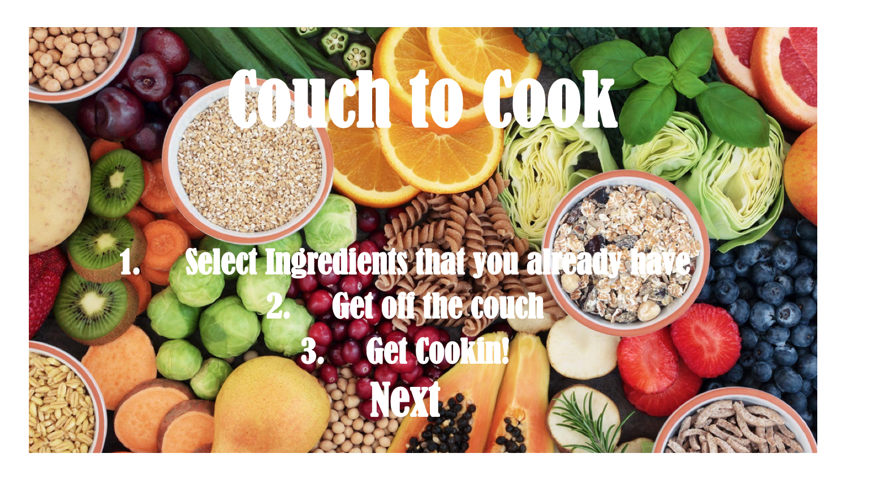

1. Choose Ingredients Page/ Recipe and Nutrition Facts (using YouTube API and specific channel ID)
   1. Two tables:
      1. Table One: Choose Ingredients
         1. choosing ingredients from image icons
         2. show selected ingredients
         3. Include search button
      2. Table Two: Get Cooking
         1. display recipe and nutrition facts below selected ingredients
         2. Refresh button to allow new ingredients to be selected, clears previous search

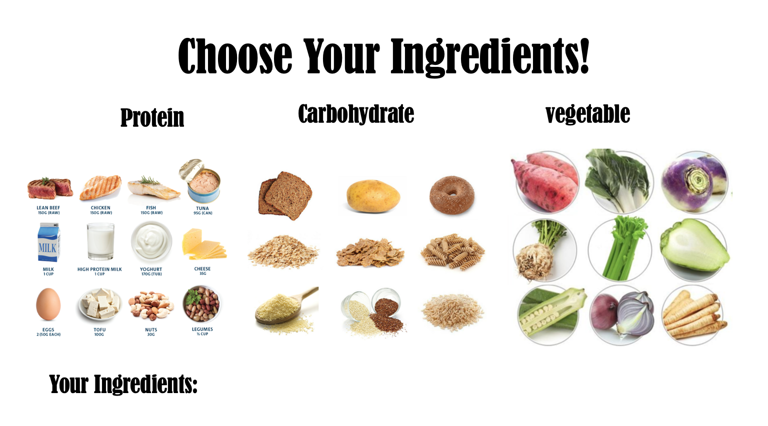

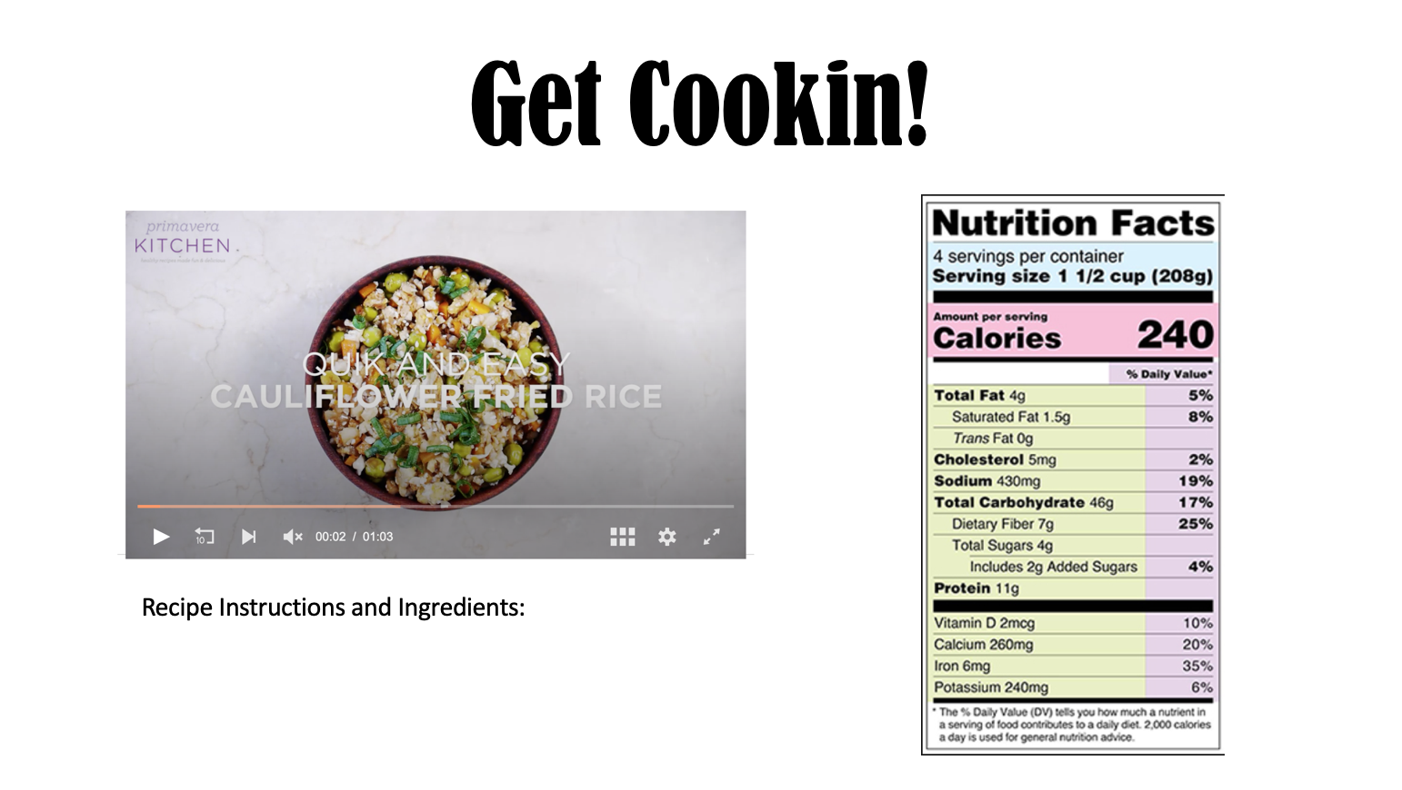

1. Feedback (hopefully something we can connect to Firebase, would let us know most popular recipes etc.)
   1. User Name, Recipe Used (maybe add a rating – 5 stars etc), Comments
   2. 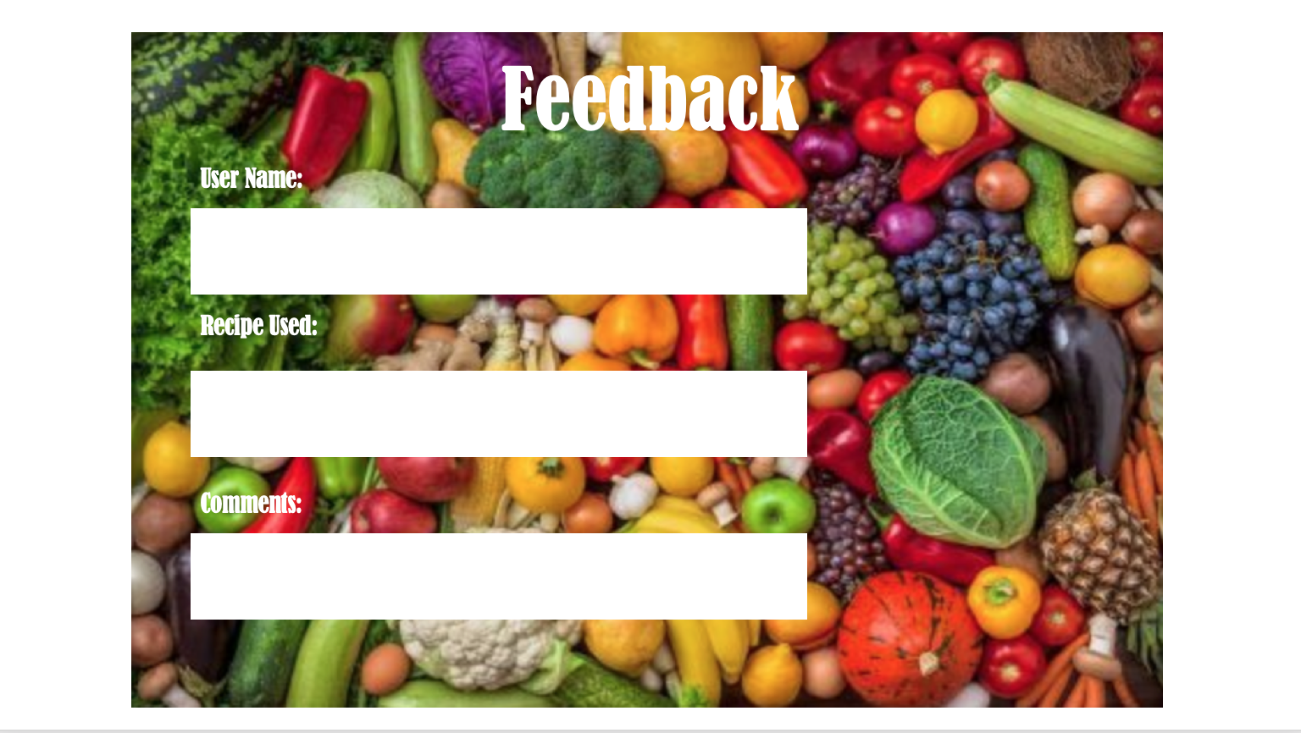Contact Us section

* Tasks: GitHub Issues and Project
  + Front End:
    - Create a skeleton for the three initial html pages
    - One Universal Styling page (css doc) using bootstrap for built in framework
    - Complete Before Thursday
  + Back End:
    - Revisit Thursday